Name :SK.Kashifa

Registration no : 192121135

Home service system :

Class diagram :

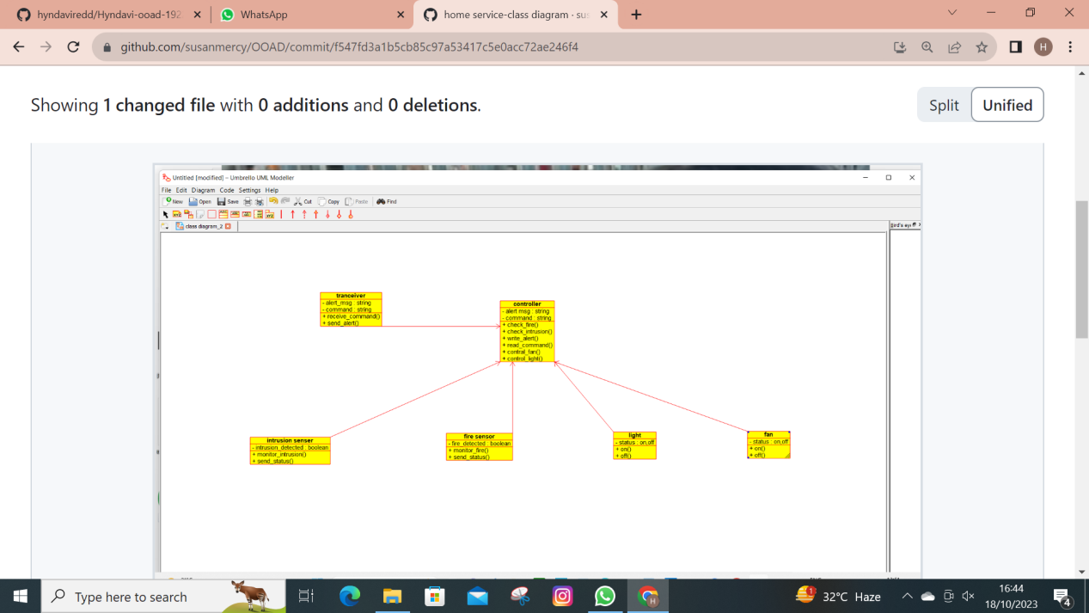

Usecase diagram :

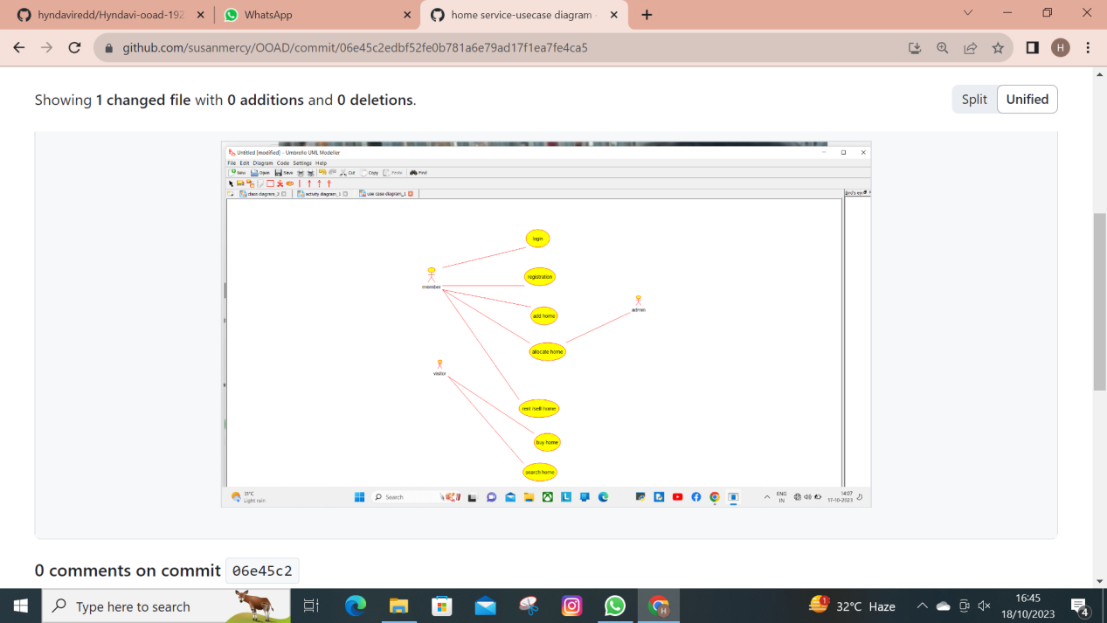

Activity diagram :

